CS6823 -‐ NEWORK SECURITY
Lab 7

Firewalling

1.Introduction

A traditional packet filter is one of the basic protection mechanisms for a network. This type of firewall can be installed and configured in several ways, depending upon the level of protection needed. In this assignment, you will explore how to configure a firewall. As usual, you will be using Linux as your base operating system; you’ll use iptables to make it act as a firewall.

Prerequisites:

Read about iptables from the following links: https://help.ubuntu.com/community/IptablesHowTo
http://www.linuxhomenetworking.com/wiki/index.php/Quick_HOWTO_:_Ch14_:_Linux_ Fire walls_Using_iptables#.VTFeMZOgapo

A firewall configuration tool can be found at: http://easyfwgen.morizot.net/

Note: ipchains is NOT iptables. Ipchains is an earlier version of a Linux firewall created by the same author. It uses much of the same terminology but processes IP packets differently especially in the processing of forwarded packets.
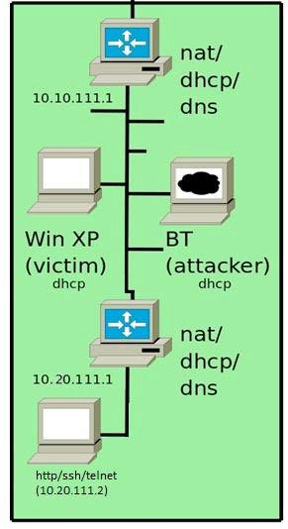
2. Lab Setup

This lab consists of an internal machine and firewall running iptables along with external machines running WinXP, Linux and Backtrack. For the purposes of this lab we won’t be using the router at 10.10.111.1 nor the “fakebook” web server. However, you are welcome to use these machines for testing if you wish.

All Firewall and NAT operations for this lab must be performed on 10.20.111.1 (internal router/firewall). If you perform the operations on the other firewall you will receive zero points.

CS6823 -‐ NEWORK SECURITY

This lab is about configuring the firewall to filter the desired traffic from the network. This is a defensive approach to disallow the unwanted machines from accessing our machine. We use the iptables to configure the firewall.

Part A:

Step 1:
Check the ip addresses of Ethernet ports. Command: ifconfig eth0

Initial iptables status for internal router 10.10.111.1before any changes to be made can be viewed using command: Iptables -L
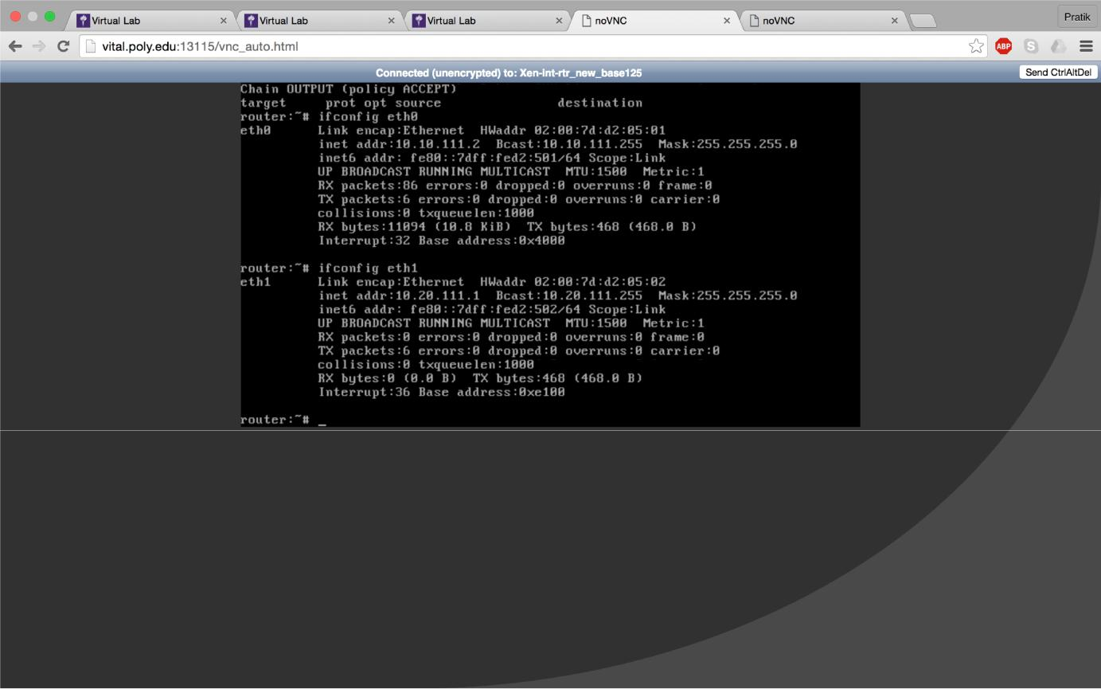

Iptables are flushed to remove all the previous rules using command: iptables -F. now checking the status again can be seen in the next snapshot.

CS6823 -‐ NEWORK SECURITY

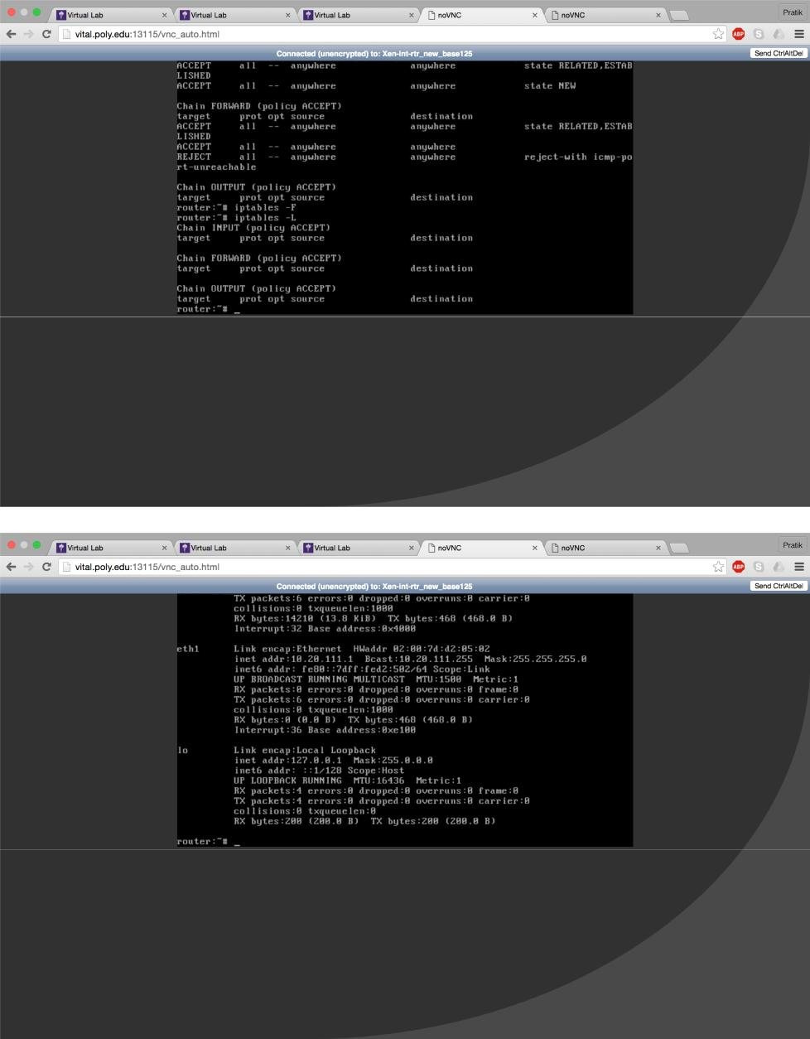

CS6823 -‐ NEWORK SECURITY

The following rules were added:

For outgoing traffic (from 10.20.111.0/24 to 10.10.111.0/24) - your internal machine should be able to communicate with the external network and the external machines without restrictions. For incoming traffic (from the 10.10.111.0/24 to the 10.20.111.0/24) - all incoming connection requests should be rejected with the following exceptions:

Commands used are shown below:
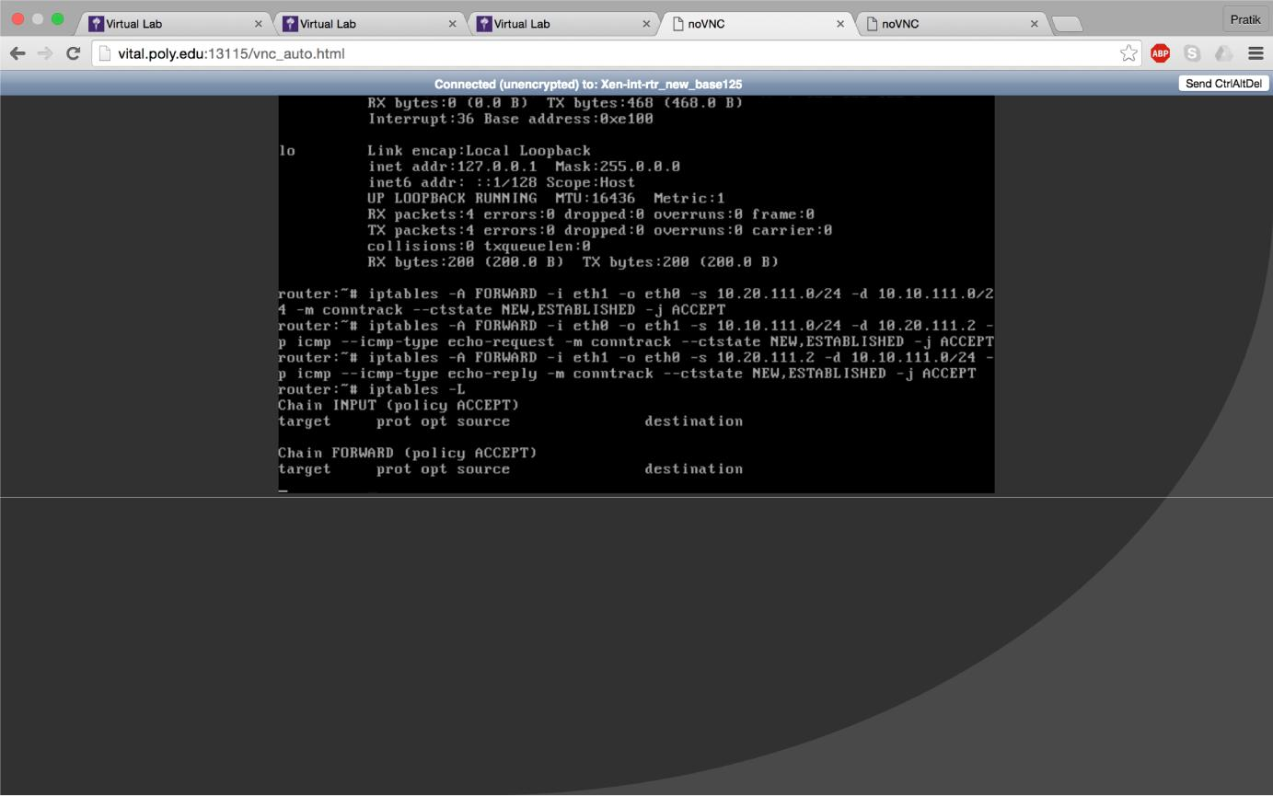

CS6823 -‐ NEWORK SECURITY

Now check the status of iptables so see the set entries
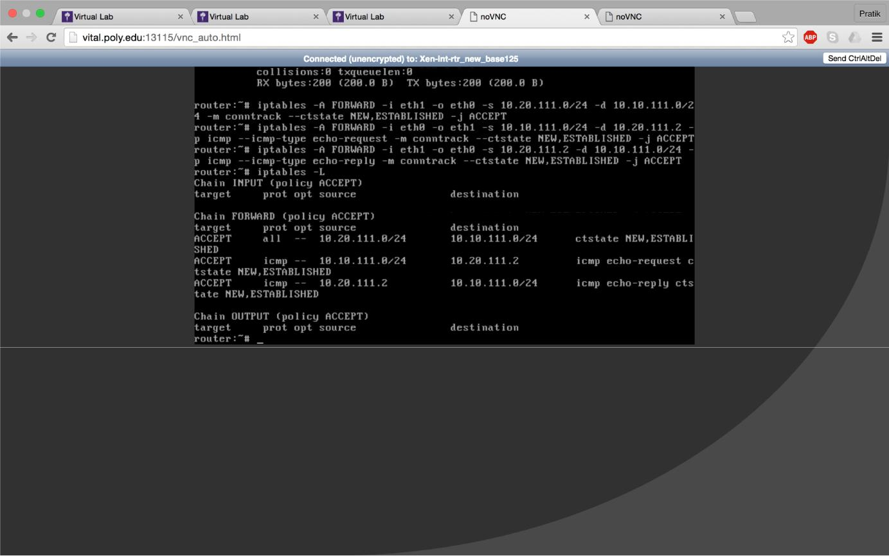

Step 2: Checking for the set configurations

Send a ping message from the internal linux machine to Windows xp machine and the bracktrack machine to check for the set configurations using command: ping 10.20.111.2

CS6823 -‐ NEWORK SECURITY

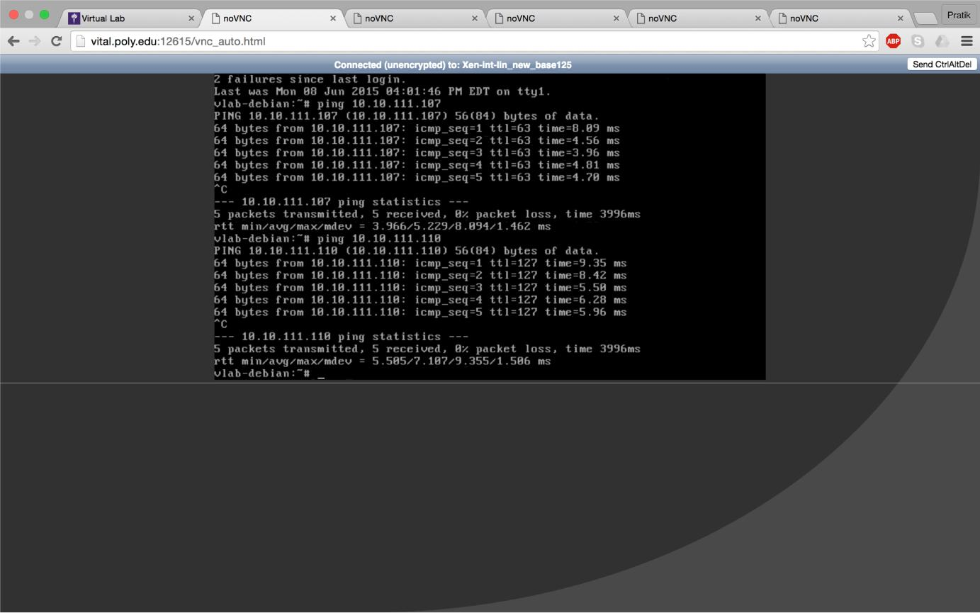

Ping message sent from the windows xp machine:
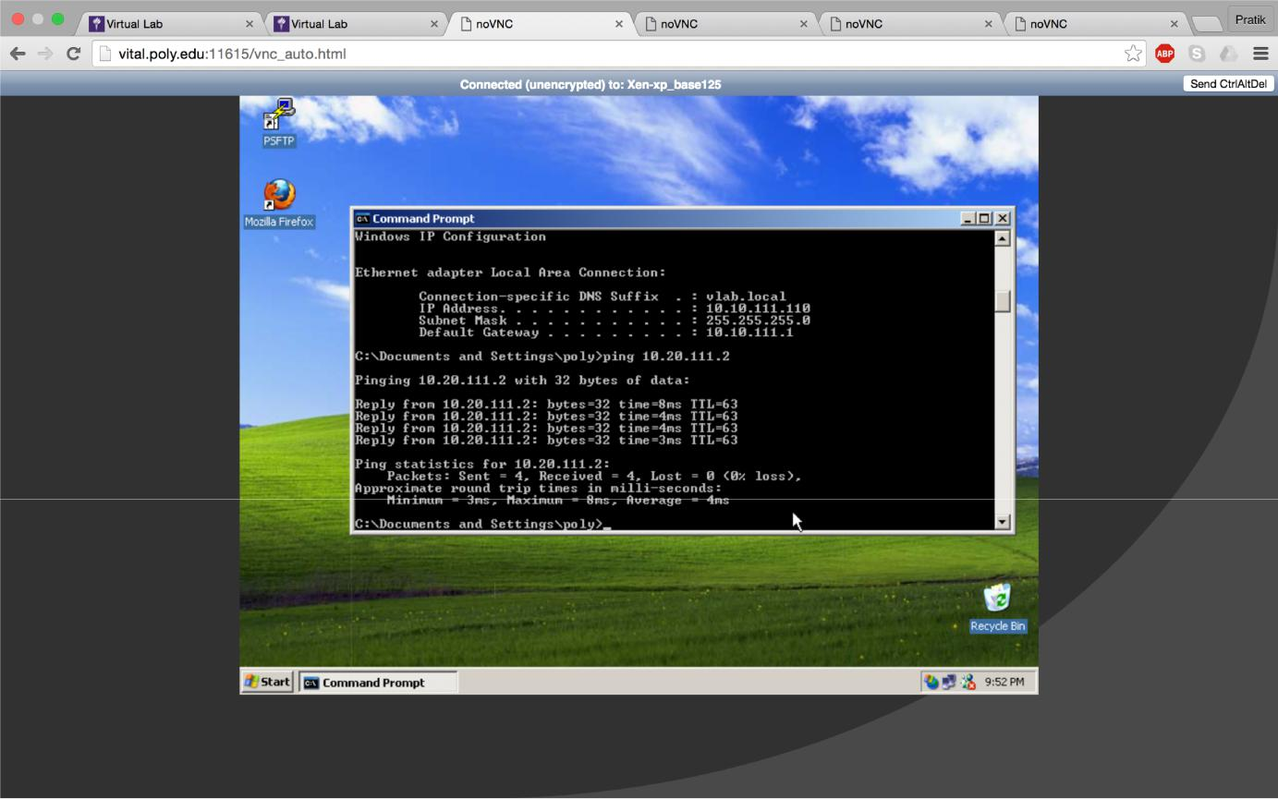

CS6823 -‐ NEWORK SECURITY

Ping message sent from the backtrack machine:

(1)ssh connection verified in this screenshot:
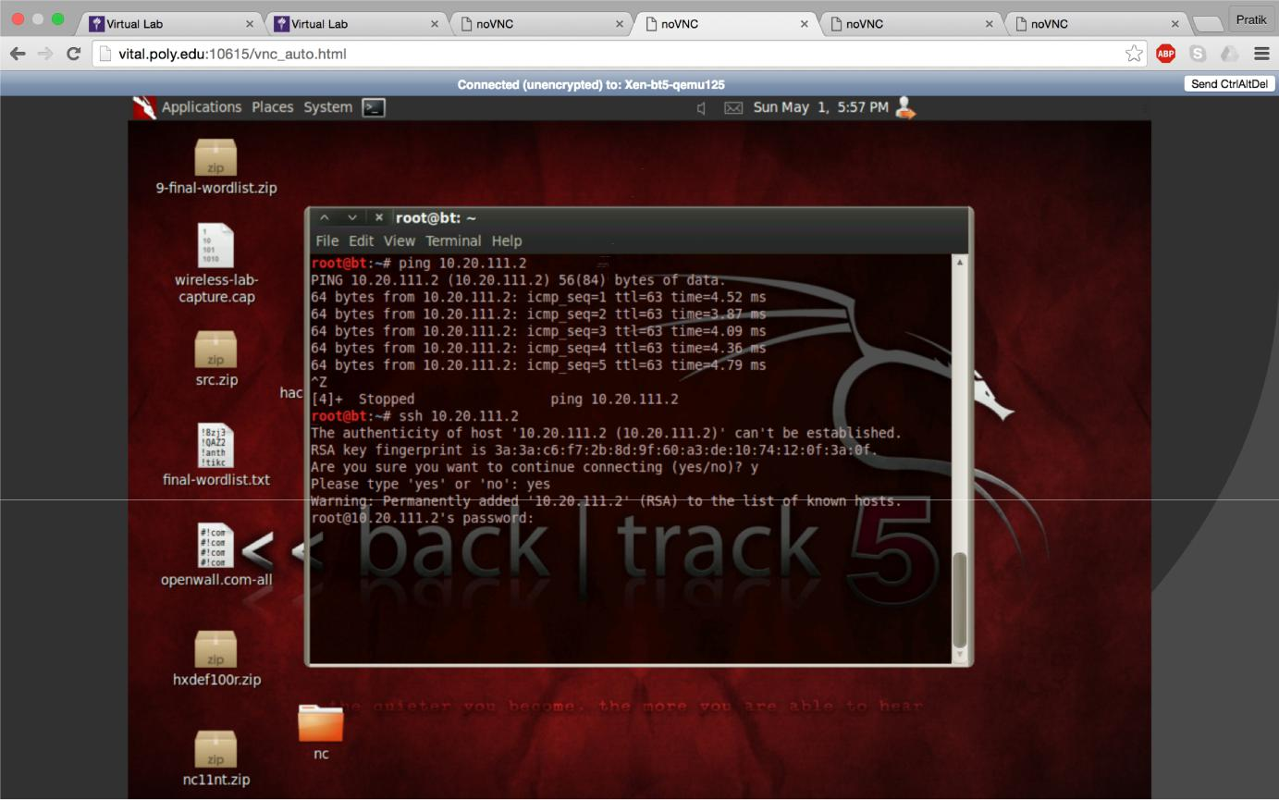

To implement rules for accepting tcp and ssh connections from 10.10.111.0/24 we use the following commands:
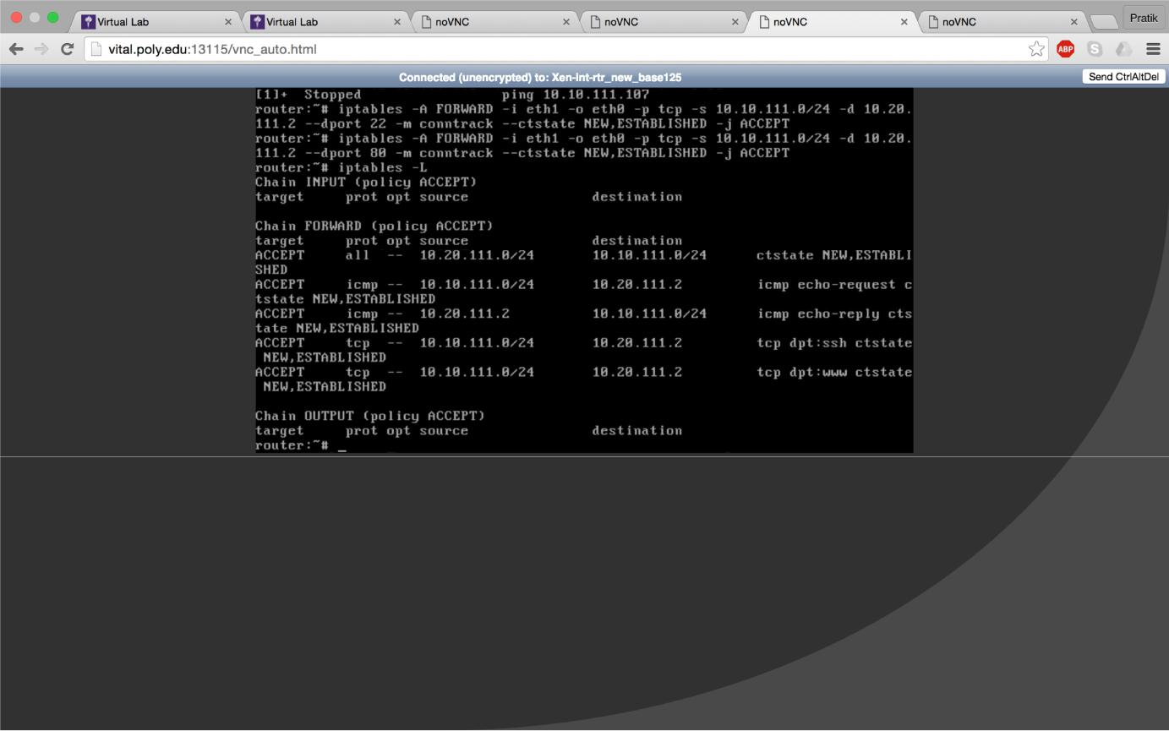

CS6823 -‐ NEWORK SECURITY

Checking http connection from windows xp machine: ssh is not a windows command
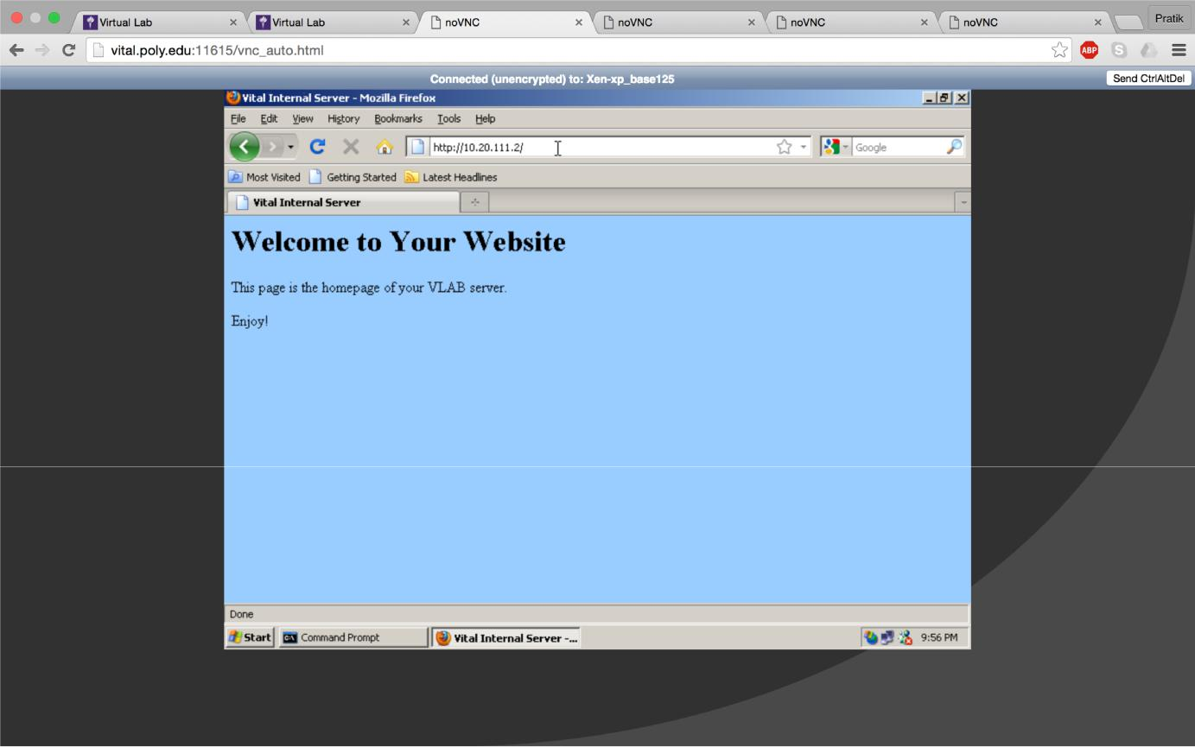

Checking http connection from bt5 machine: ssh connection is verified in screenshot (1):
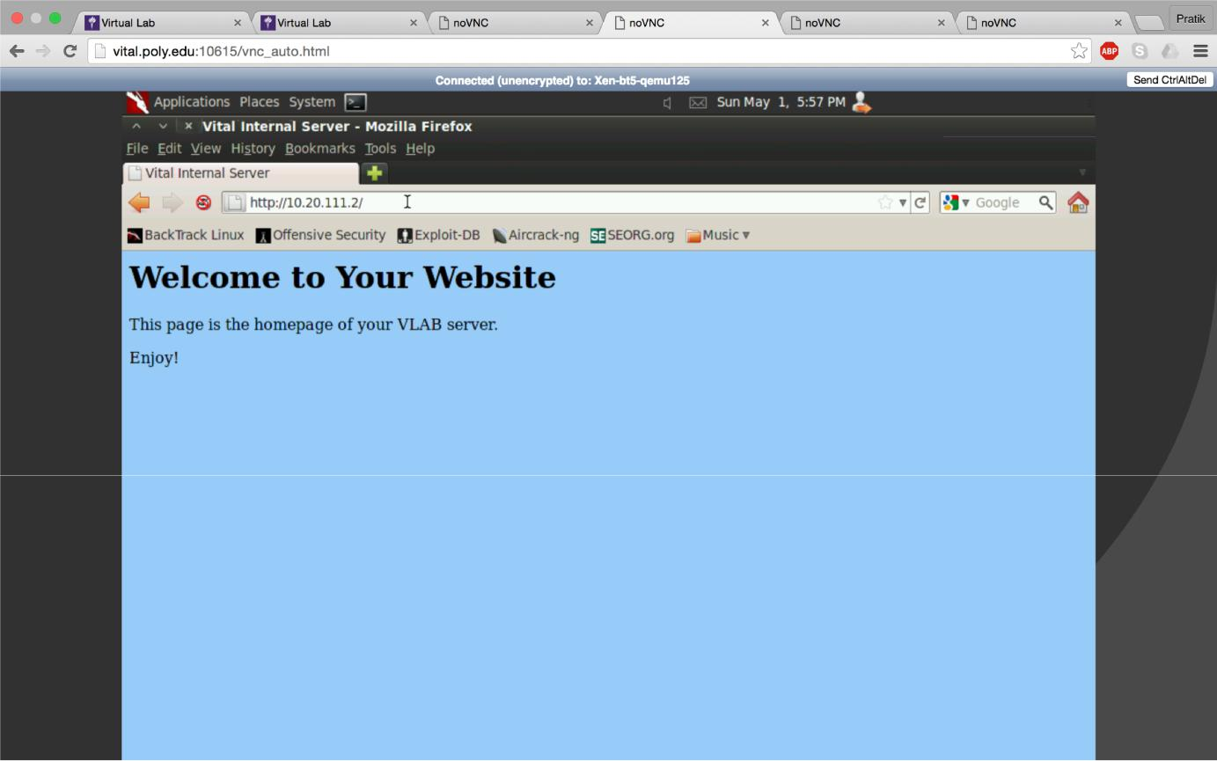

CS6823 -‐ NEWORK SECURITY

The specified set rules allow a telnet connection to the internal from the backtrack machine and not from the windows machine. We can confirm these using command telnet 10.20.111.2
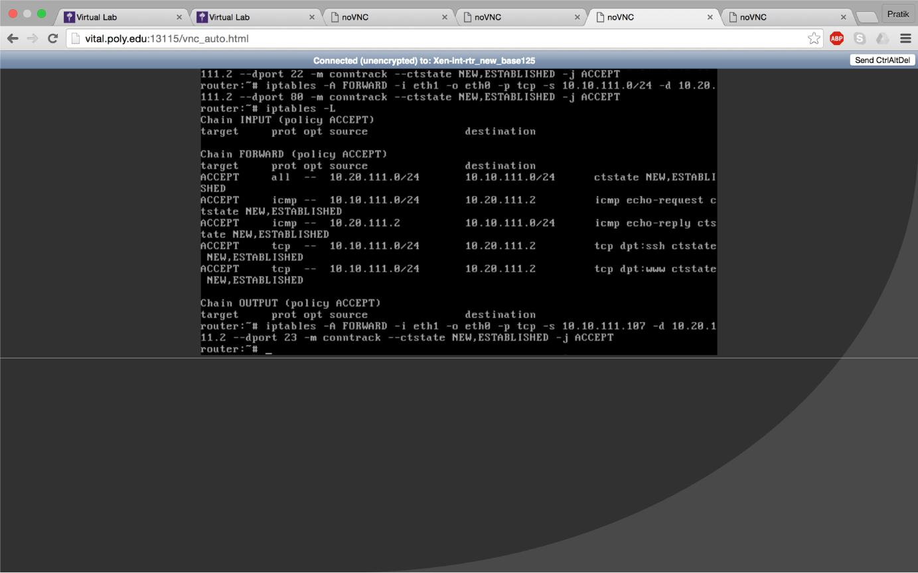

telnet works in backtrack 5 machine:

dhclient, provides a means for configuring one or more network interfaces using the Dynamic Host Configuration Protocol, BOOTP protocol, or if these protocols fail, by statically assigning an address.
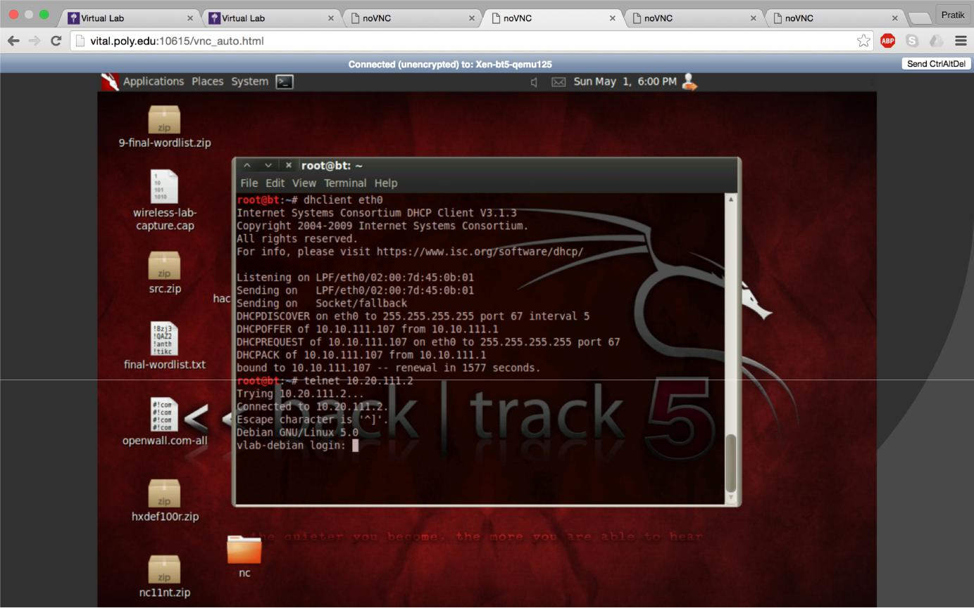

CS6823 -‐ NEWORK SECURITY

Part B: step 1:

Flush the previous setting in the iptables using iptables -F. Now add the NAT policies as specified in the lab. Use the commands as shown in the next screenshot.
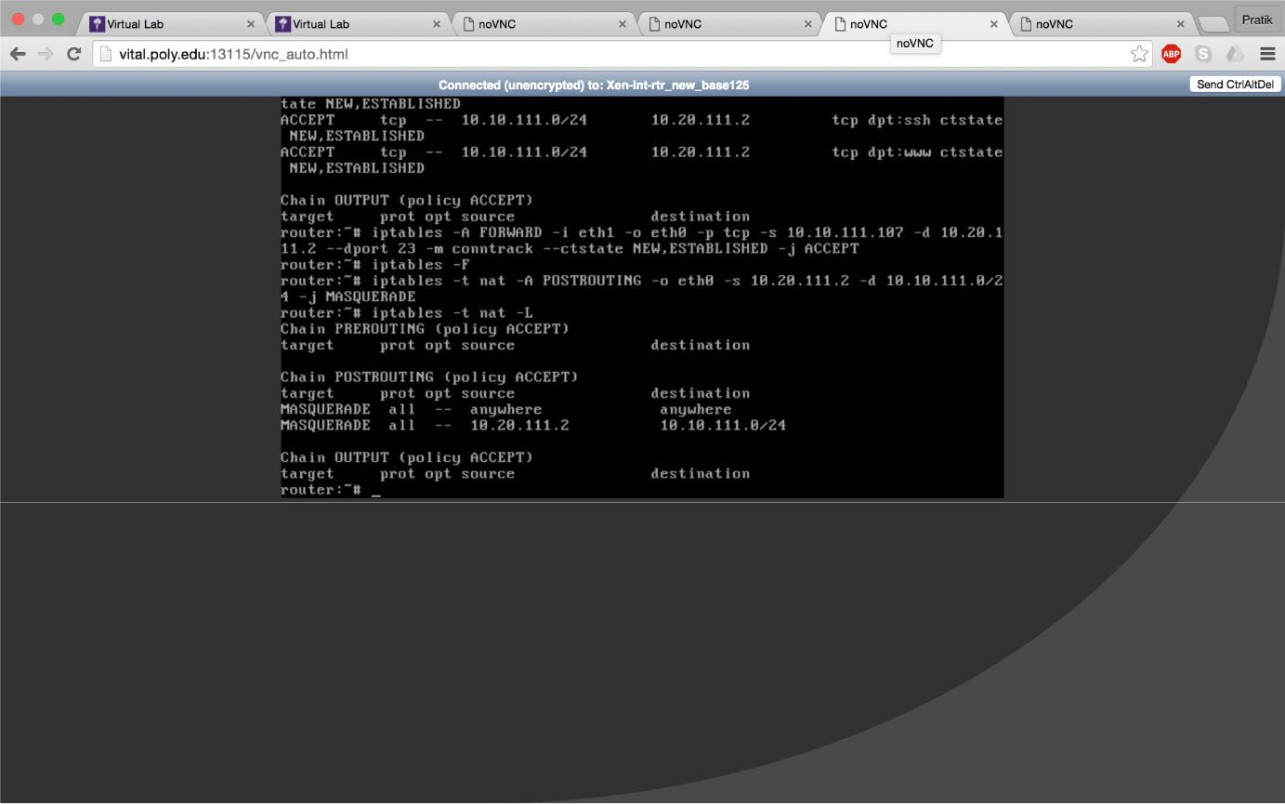

Step 2:

send a ping command from the internal linux server to the backtrack machine, to confirm the NAT configurations were successfully set. Use command:

ping 10.10.111.106

CS6823 -‐ NEWORK SECURITY

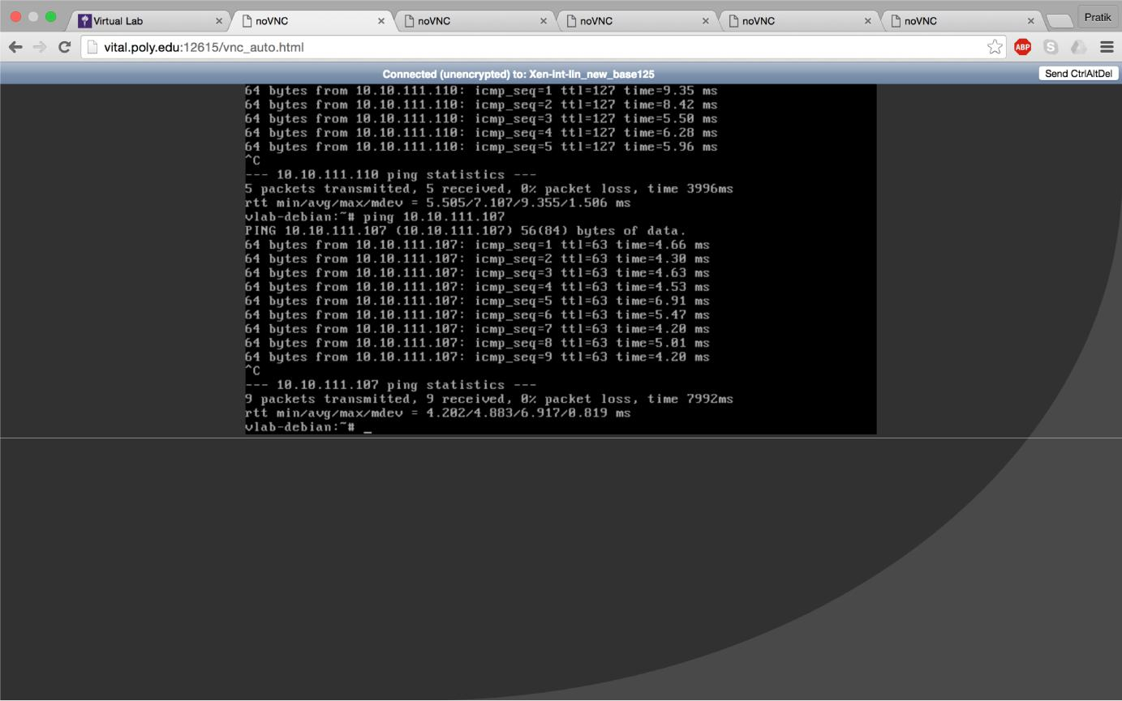

Step 3:

In the backtrack machine start wireshark to capture the packets of NAT operations.

We can see that the source ip address of the ping is that of the internal router interface. From this we can see that the internal server’s ip has been replaced with the internal routers interface that is eth0. Thus we can say that the NAT operations were successfully performed.

Also we can perform the ssh we can see that the NAT operation was performed successfully from the following screenshot.
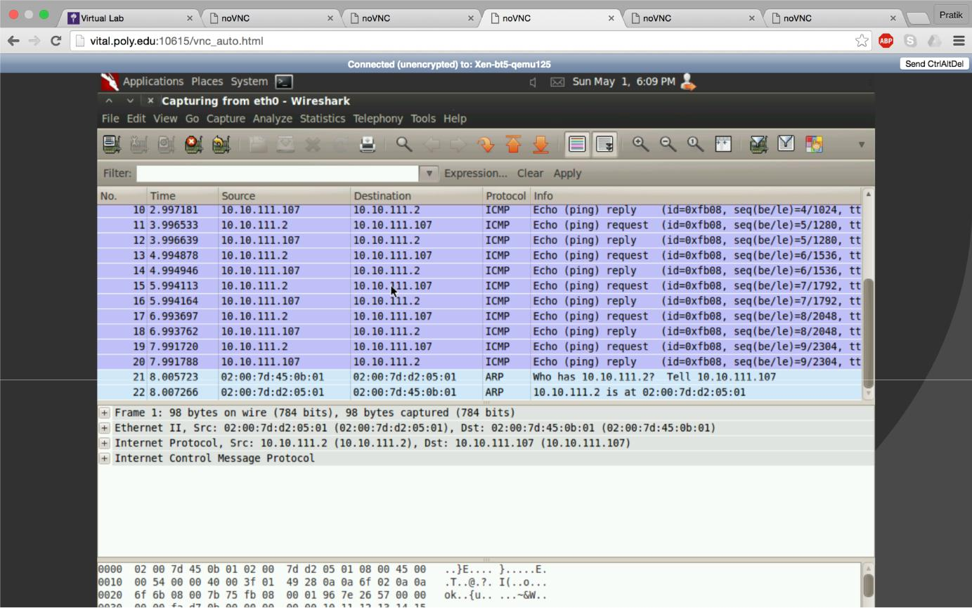
CS6823 -‐ NEWORK SECURITY

In order to do ssh we need to generate ssh keys. Which is done as follows:
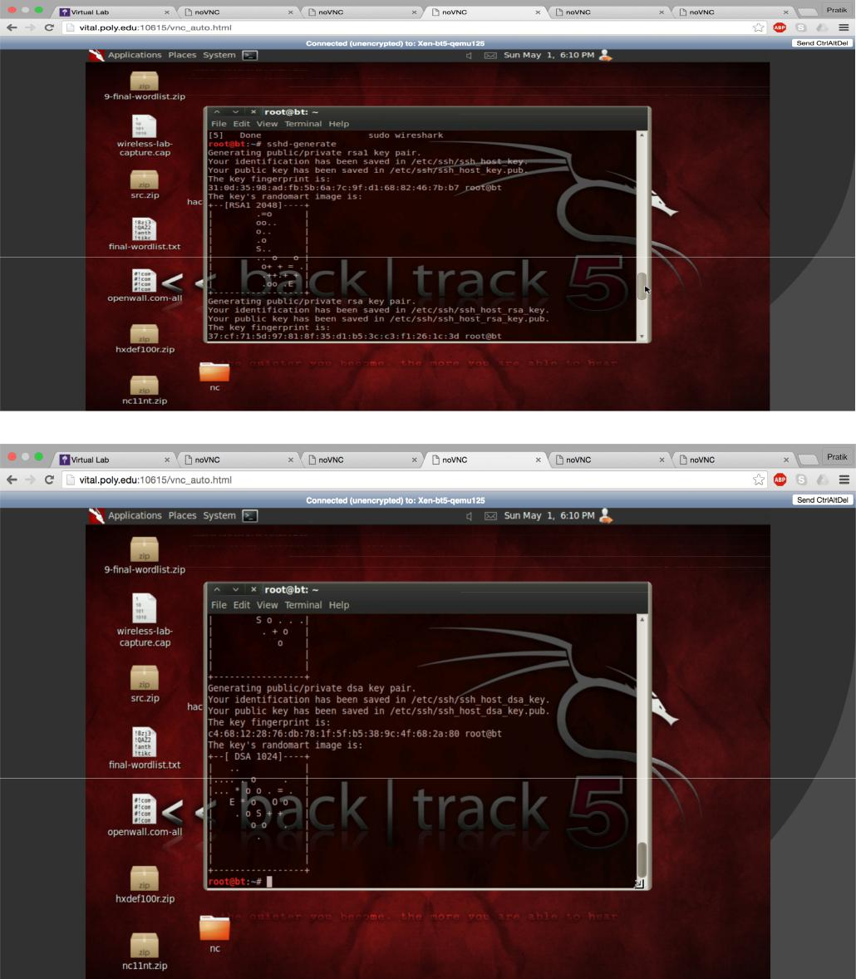

CS6823 -‐ NEWORK SECURITY

ssh start to start ssh servive on BT5 machine. Ssh stop to stop ssh service on BT5 machine.
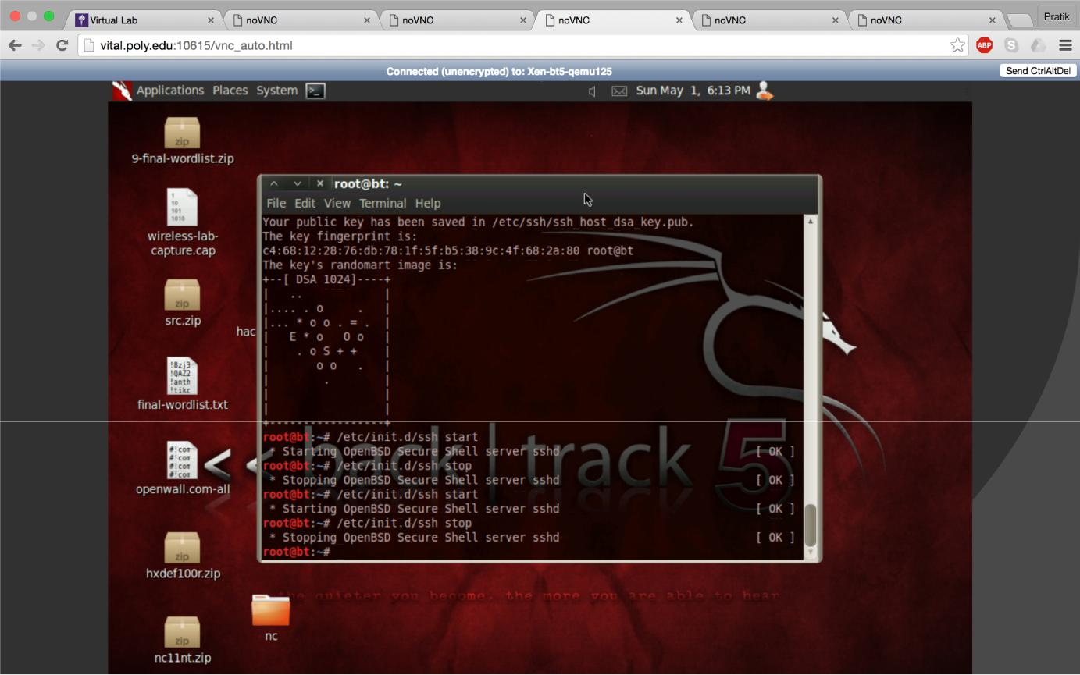

After executing ssh we can see that the remote host identification has changed. After a couple of ssh login’s, it shows us the following screen, that “it is possible that someone is trying to eavesdropping on you
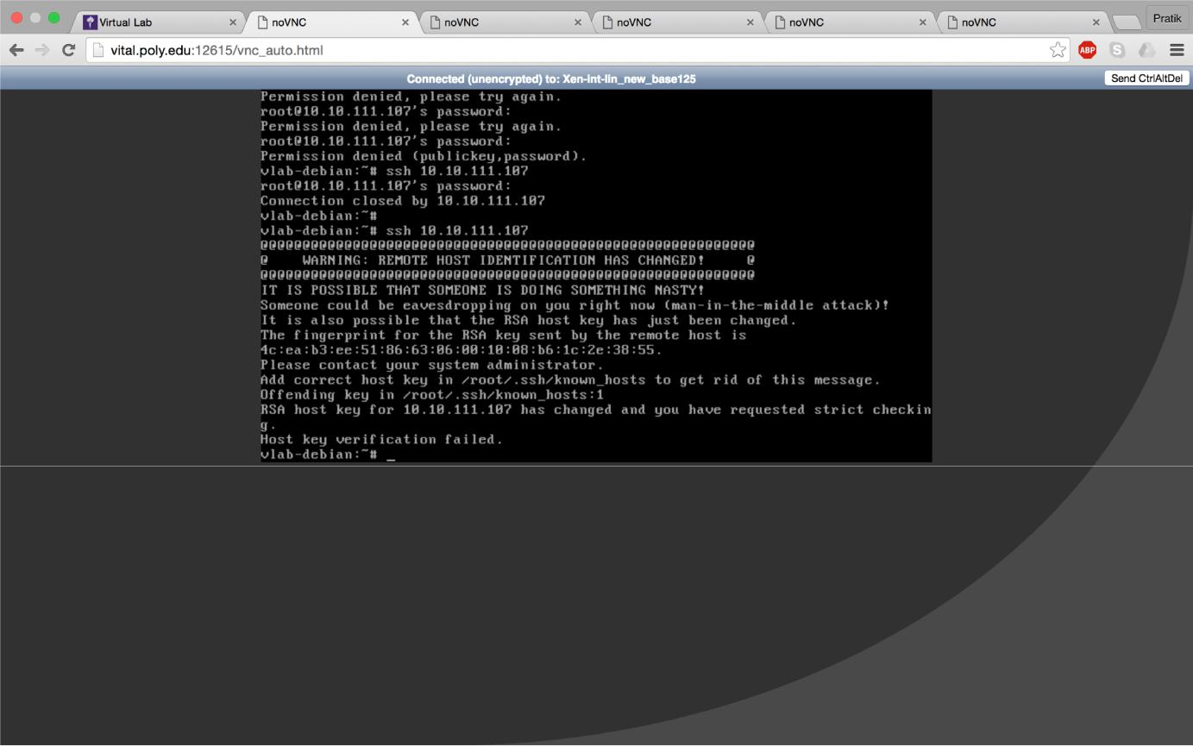
Part C:

- In your own words describe how iptables work. Answer:
● Iptables are used to configure the firewall by setting the rules to filter the network traffic. The set of rules are called as chains.

● Policies are defined in the IPtables. There are the default rules that have been set in the IPtables and which are applied in case no rules are set by us.

● Types of policies:

  - INPUT: traffic coming to the machine

  - OUTPUT: traffic going out of the machine

  - FORWARD: traffic coming to and going out of the machine on the other side of the firewall.

- What is the difference between input, output and forward

chains? Answer:

INPUT CHAIN: rules that are considered for packets destined to the machine from some source.

OUTPUT CHAIN: rules that are considered for packets originating from machine destined for other machines.

FORWARD CHAIN: rules for packet that has to be passed from one interface to another will be passed to the FORWARD chain.

3. What is the difference between drop, reject and accept? Answer:

ACCEPT: Allow the packets. DROP: Disallow the packets.

REJECT: Disallows the packets but also informs the source by sending an error packet.

CS6823 -‐ NEWORK SECURITY

4. Do some research and find some alternative network based firewalls (at least 3). List and describe the pros and cons of each when compared to iptables. The alternative

can be commercial, open source or even a stand along appliance. Answer:

Juniper Network's Net-screen

The Juniper Networks NetScreen-5000 series is a line of purpose-built, high-performance firewall/VPN security systems designed to deliver a new level of high-performance capabilities for large enterprise, carrier, and data center networks. Net-screen is easier to configure as compared to Iptables because of the proprietary GUI. It offers excellent scalability and flexibility while providing a higher level security system through Juniper Networks Net-Screen ScreenOS

custom operating system as compared to Iptables.

Cisco Pix:

Cisco PIX is a hardware based firewall as compared to Iptables which is software based. Hardware-based firewalls like the PIX typically boot faster than their OS-dependent counterparts, do not experience boot-time errors, and are simpler to upgrade. One benefit of the PIX is that it requires no special client side software other than ssh, telnet, tftp or serial port terminal

software. Cisco Pix is said to have better availability and management as compared to Iptables. Iptables are easier to configure as compared to PIX.

Comodo Firewall Pro:

It is a software based firewall.It has a obtrusive system monitor. It is harder to use as compared to Iptables. It's pros are free and minimal system drag.

